# TCS-Gadget Sales Management

**BY: V.Divya Syamala**

**PHASE- 1: Problem Understanding & Industry Analysis**

**Requirement Gathering**

* Lack of automation in gadget sales management.
* Poor inventory management leading to stockouts or overstocking.
* Weak customer engagement and limited personalized sales support.
* Need for an automated and customer-centric system using Salesforce.
* Integration with smart devices, wearables, gaming accessories, mobile accessories, and eco-friendly gadgets.

**Stakeholder Analysis**

* High Power – High Interest (Manage Closely): Customers, Sales Executives, Store
* Managers.
* High Power – Low Interest (Keep Satisfied): Top Management, Decision Makers.
* Low Power – High Interest (Keep Informed): Suppliers, Marketing Teams, Delivery
* Partners.
* Low Power – Low Interest (Monitor): IT / Salesforce Admins.
* Stakeholder Power-Interest Grid

1. High Power – High Interest: Manage Closely  Engage regularly and prioritize their needs (e.g., Customers, Sales Executives, Store Managers).
2. High Power – Low Interest: Keep Satisfied  Provide updates without overwhelming them (e.g., Top Management).
3. Low Power – High Interest: Keep Informed  Share progress and keep them engaged (e.g., Suppliers, Marketing Team, Delivery Partners).
4. Low Power – Low Interest: Monitor  Minimal involvement, only engage when necessary (e.g., IT Admins, Regulators).

**Business Process Mapping**

1. Customer interest  Order  Inventory check Payment Delivery  After-sales support.
2. Analytics system to track customer movement and improve store layout.
3. Integration with predictive analytics to identify customer trends and enable targeted campaigns.

**Industry-specific Use Case Analysis**

* Traditional Retail Sales: Streamlines inventory tracking, prevents stockouts, and uses AI-powered purchase history recommendations.
* E-commerce & Online Marketplaces: Automates sales orders, enables real-time shipment tracking, integrates augmented reality for visualization.
* Telecommunications & Mobile Providers: Manages bundled gadgets, subscription management, upgrades, and personalized plans.
* Business-to-Business (B2B) Sales: Handles large-scale sales cycles, automated follow-ups, AI-powered insights, and proactive support.
* Small Businesses & Repair Shops: Focused on efficiency, ensures availability of repair parts, and provides customer-centric tracking interface.

**AppExchange Exploration**

1. Define needs clearly – Identify specific challenges like inventory management or

e-commerce integration.

1. Search the AppExchange – Explore tools for analytics, customer service, or

industry-specific solutions.

1. Filter results using pricing, ratings, features, and Salesforce compatibility.
2. Evaluate listings – Review summaries, technical details, and provider capabilities.
3. Test the app – Use sandbox or free trial to check functionality with business data.
4. Install safely – Deploy in sandbox first before moving to production.

**PHASE-2: Org Setup & Configuration**

# Salesforce Editions:

* Use **Developer Edition Developer Org** (free dev org)

# Company Profile Setup

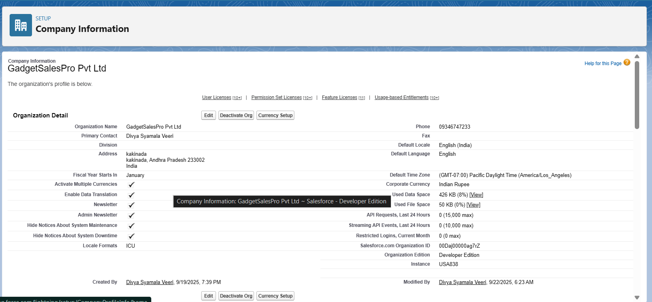

# Business Hours & Holidays:

# working hours (9am–6pm).

# Add public holidays(like new year, Independence day)

# Fiscal Year Settings:

# Standard (Jan–Dec) → good for reporting.

# User Setup&Licenses:

* Creating users & profiles : Sales Manager -> Custom Sales Manager Profile, Accountant -> Accountant Profile, Sales Rep->Custom Sales Rep Profile them Salesforce licenses.

|  |
| --- |
|  |

# Roles:

|  |  |
| --- | --- |
| * Sales Executive | * Can edit all cases associated with accounts they own |
| * Sales Representative | * Cannot access cases they do not own |
| * Store Manager | * Can view all cases associated with accounts they own |

Permissions:

|  |  |  |
| --- | --- | --- |
| Profile | Object Access | Notes |
| System Administrator | Full access to all objects & fields | For admins |
| Sales Executive | Read/Edit Sales Transaction, Gadget, Account | Cannot delete critical objects |
| Sales Representative | Read/Edit Sales Transaction, Gadget | Limited access to Accounts & Contacts |
| Marketing User | Read Accounts & Contacts, View Sales Reports | Cannot create Sales Transactions |

CEO

└── Sales Executive

└── Store Manager

└── Sales Representative

# OWD:

* Decide who can see Sales Transactions, Accounts, Gadgets by default
* **Private for Sales Transactions** → only owner or users above in the role hierarchy can see
* **Public Read-Only for Gadgets** → all users can see gadget info

# Login Access Policies:

* Ensure secure access for Sales Reps and Executives
* Admin can troubleshoot issues by logging in as a user

# Dev Org Setup:

* Configure apps, objects, fields, users, roles, and profiles
* Enable features needed for automation and reporting

# SandBox Usage & Deployment Basics:

* Test new flows, validation rules, and Apex triggers **without affecting real data**
* After testing in sandbox, deploy gadget objects, fields, and automation to live org

**Phase 3: Data Modeling & Relationships**

• **Standard & Custom Objects**

* **Custom Objects created:** Gadget, Sales Transaction.
* **Standard Objects used:** Account, Contact, User.
* **Purpose:** Store gadgets, sales records, customers, and buyers.

• **Fields**

* Gadget fields: Name, Category, Brand, Model No, Price, Warranty, Stock Quantity.
* Sales Transaction fields: Quantity, Gadget Price, Total Amount (formula), Delivery Date, Order Date, Customer, Buyer Contact, etc.
* **Purpose:** Capture all relevant information for gadgets, transactions, and deliveries.

• **Page Layouts**

* Account Page Layouts include Contacts and Sales Transactions related lists.
* Gadget Page Layout includes Sales Transactions related list.
* **Purpose:** Simplifies data entry and displays related records clearly.

• **Lookup vs Master-Detail Relationships**

* **Lookup relationships:** Sales Transaction → Gadget, Sales Transaction → Customer (Account), Sales Transaction → Buyer Contact (Contact).
* **Purpose:** Link related records; e.g., a Sales Transaction is linked to a specific Gadget and Customer.

**Phase 4: Process Automation (Admin)**

• **Validation Rules**

* Rules created to ensure data integrity in Sales Transactions:
  + **Quantity > 0** → Prevents saving zero or negative quantities.
  + **Sale Date not in the future** → Ensures realistic sale dates.
  + **Total Amount formula** → Checks that Total Amount = Quantity × Gadget Price.
* **Purpose:** Ensures users cannot enter incorrect or inconsistent data.

• **Flow Builder (Record-Triggered Flow)**

* Flow created to **auto-fill Gadget fields** in Sales Transactions when a Gadget is selected:
  + Gadget Price, Brand, Category, Warranty copied automatically.
* **Purpose:** Reduces manual entry errors and speeds up data entry.

**Phase 5: Apex Programming (Developer)**

• **Classes & Objects**

* Apex class SalesTransactionHandler created to handle Sales Transaction operations.
* **Purpose:** Encapsulates logic for Sales Transactions, keeps code organized and reusable.

• **SOQL & SOSL**

* Used in Flows and Apex to query Gadget or Account/Contact records.
* **Purpose:** Retrieves data needed for automation and transaction processing.

• **Control Statements**

* Basic if/else conditions and loops are applied in Apex class and flow logic.
* **Purpose:** Handles decision-making in transaction automation.

• **Apex Triggers (partially)**

* Triggers for Sales Transaction creation/updates were discussed but not fully deployed yet.

**Phase 6: User Interface Development**

• **Record Pages & Tabs**

* Account, Gadget, and Sales Transaction objects have pages and related tabs.
* **Purpose:** Allows users to navigate easily and view related records.

• **Home Page Layouts**

* Basic layouts for easy access to records and dashboards (if created).
* **Purpose:** Improves user experience and quick access to key information

**Phase 7: Integration & External Access**

1. **Remote Site Settings**
   * If you configured Authorize.Net integration, the remote site would be set.
   * **Purpose:** Allows Salesforce to make callouts to external payment services securely.

**Phase 8: Data Management & Deployment**

**VS Code & SFDX**

* Used to **create Apex classes**, retrieve/deploy metadata, and manage your Salesforce project.
* **Purpose:** Provides a development environment to code, deploy, and manage Salesforce metadata efficiently.

**Reporting, Dashboards & Security Review**

• **Reports**

* Basic reports can be created on **Sales Transactions** and **Gadgets**.
* **Purpose:** Allows tracking of monthly sales, gadget-wise sales, and customer interactions.

• **Report Types**

* Standard and custom report types for **Sales Transaction** and **Gadget** objects are available.
* **Purpose:** Define which fields and objects are available for reporting.

• **Sharing Settings**

* Organization-wide defaults (OWD) and lookup/master-detail sharing are configured.
* **Purpose:** Controls which users can see or edit records.

• **Field Level Security**

* Profiles have field access control (e.g., Force.com - App Subscription user).
* **Purpose:** Ensures sensitive data is visible only to authorized users.